FNMS – JAMF Pro Management Inventory Adapter

# Design Overview

This solution connects to a JAMF Pro tenant to bring in Computer Hardware and Software Inventory into FNMS.

This integration runs the following:

* Data extraction from JAMF using PowerShell script
* Flexera Inventory SaaS Object Adapter Framework encapsulates the data for deliver to the Processing Server
* Compliance import execution to process the above datasets to calculate a license consumption

The following information will be collected:

* Computer Hardware
* Installed Software

## JAMF Pro Inventory Adapter Import

### Pre-requisites

#### Software Components

The following software is required in JAMF for the PowerShell script to collect data for published applications:

* Classic REST API
* User created with read access to Computer and Software information as well as access to the API

On the FNMS/Beacon:

* PowerShell 3.0 or later, must be installed.
* FNMS 2017 R3+

#### Configuration

The PowerShell sessions must allow un-signed scripts to run.

#### Security Configuration

The Flexera connector requires a local JAMF account with access to Computer, Software, Advanced Computer Search and the Classic API. 2 PS1 files are included. Both require the Username and Password for the local JAMF Account, however they work a bit differently. If you are using 10.35.0 or later, use the Logic.TOKEN_AUTH.ps1 file as Basic Authentication directly to the API is being turned off by JAMF. Pre 10.35.0, use Logic.BASIC_AUTH.ps1 as the token method cannot be used to access to the API. In both scenarios, a local account with ID and PW are required as tokens are only available for 30 minutes and cannot be pre-authorized for a longer period of time for use. With the Token method, the credentials will only be used to generate the Token, not to access the API directly.

## Configuring JAMF Pro Saved Searches

The inventory adapter relies on 2 Saved Searches. One is created to generate the information needed for Hardware and one for Software. These should be saved with a unique name that will be utilized during the configuration of the Inventory Adapter. If the searches are renamed, they must be updated in the Inventory Adapter Configuration.

The **Hardware Saved Search** should contain the following information:

Computer

* Computer Name
* IP Address
* JSS Computer ID
* Last Inventory Update

Hardware

* Architecture Type
* MAC Address
* Make
* Model
* Model Identifier
* Number of Processors
* Processor Speed MHz
* Processor Type
* Serial Number
* Total Number of Cores
* Total RAM MB

Operating System

* Operating System
* Service Pack

User and Location

* Email Address
* Username

The **Software Saved Search** should contain the following information:

Computer

* Computer Name

Assets

* Applications

## Configuring Inventory Adapter

Extract the JAMF Pro folder from the zip file.

On the FNMS Inventory Beacon:

* Copy the **JAMF Pro** folder to C:\ProgramData\Flexera Software\Compliance\ImportProcedures\ObjectAdapters\Reader
* Depending on your version, rename EITHER *Logic.BASIC_AUTH.ps1* OR *Logic.TOKEN_AUTH.ps1* to **Logic.ps1**

**Launch the Beacon UI**

Configure a PowerShell connection to the JAMF URL and set the adapter type to JAMF Pro

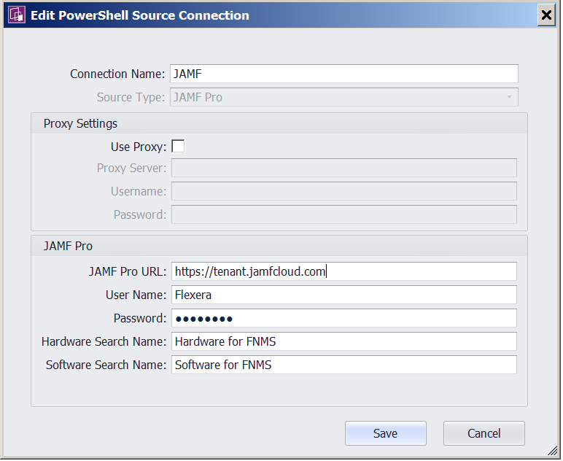

**JAMF Pro URL:** URL directly to the JAMF Pro tenant.

**User Name:** User Name for account in JAMF Pro with access to data and web services

**Password:** Password for account in JAMF Pro with access to data and web services

**Hardware Search Name:** Name of the Saved Search for Hardware as defined in the JAMF Pro Configuration Step.

**Software Search Name:** Name of the Saved Search for Software as defined in the JAMF Pro Configuration Step.

After the data is imported, you will see the Inventory data imported into FNMS.

# Data Validation in FNMS

## Where does the imported JAMF Pro data go?

Computers and related Software Installations may be found in Inventory.

**Inventory**

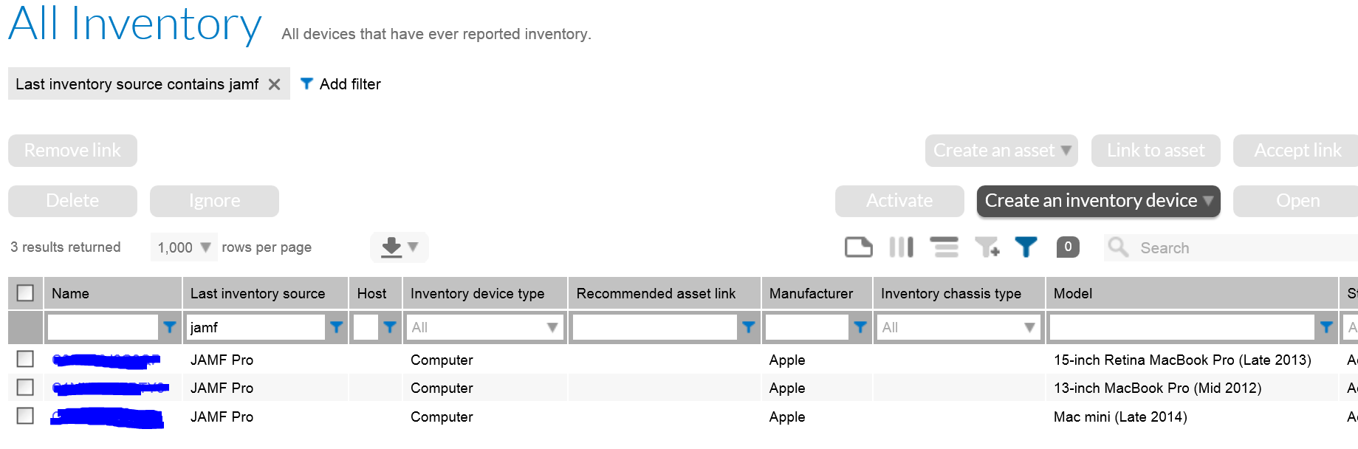

**Installed Applications**

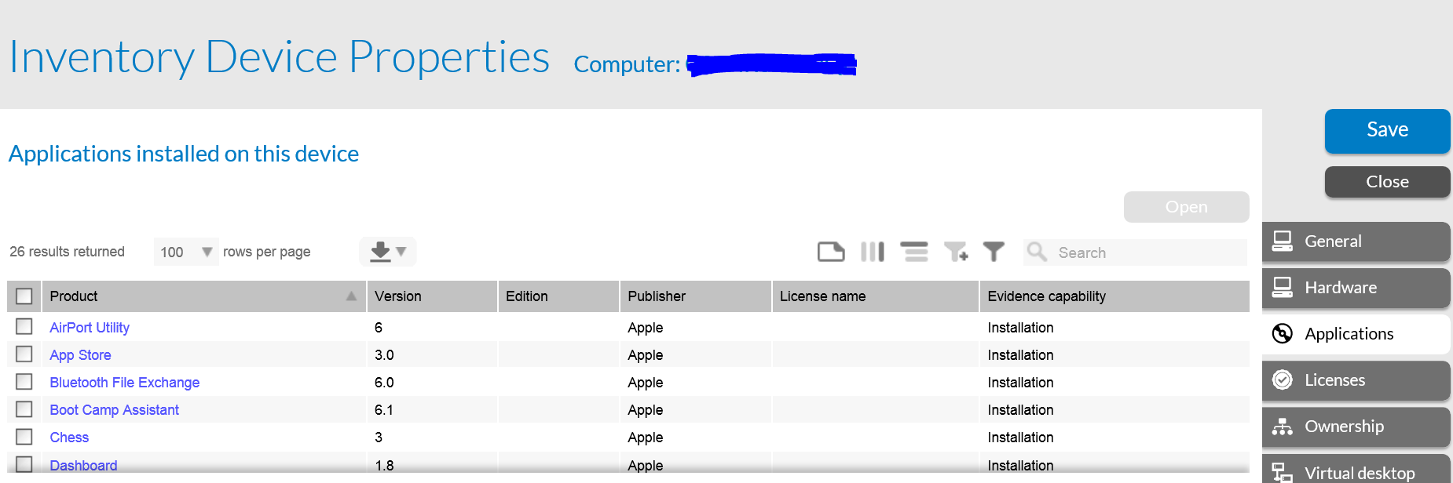

# Appendix

## JAMF Pro-FNMS Integration Data Flow

